changess

Activity 1

GitHub

Your assessment for this module should be submitted using GitHub. Git is a technology that you’ll need to be familiar with in industry so it’s a great time to learn it for your future career too! You should return to this guide each time you need to create a new GitHub repository using GitHub Classrooms.

Please note, for non-assessed work (i.e. in-class activities) you should be creating your own GitHub repository. Just visit GiHub.com and click “Create” once logged in. You should still use this activity to create your assignment repository and for guidance with your own repository.

**Step 1.** Visit the GitHub.

**IMPORTANT: When creating an account in the next step PLEASE use your name when setting your GitHub username. If you already have a GitHub account and your username does not resemble your name, please create a new account. Else your tutor will not know it is you committing your assessments!**

**Step 2.** If you have used GitHub before, then login to your account. However, if you’re new to GitHub then complete the registration once your account has been created, you should see something like the screenshot below:

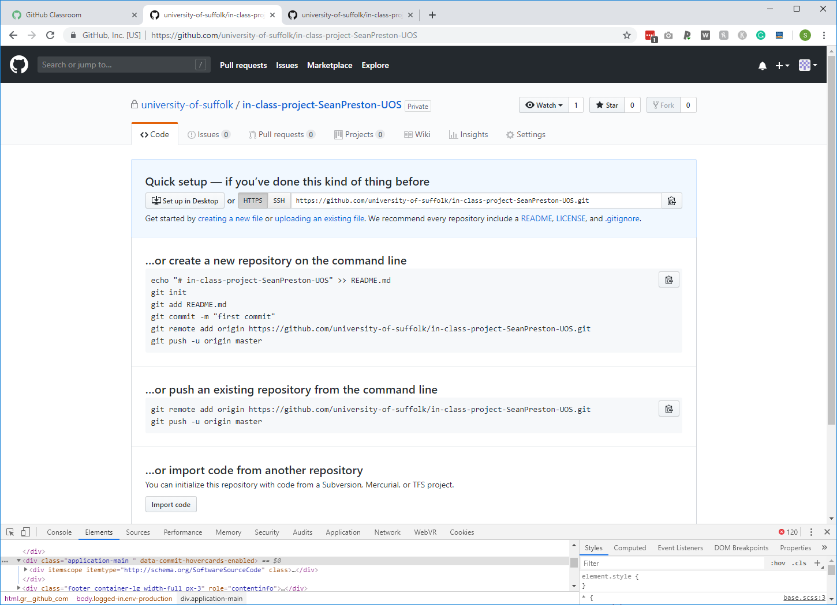

**Step 3.** We now need to be able to commit data to this repository. There are two primary ways of doing this. Either we can commit using the command line or the GitHub Desktop Client. For the purpose of this module, using the Desktop Client is fine. You may find (especially if your using a lab PC) that the GitHub client has already been installed. If so, please skip to step 6. If not or if you’re using your own machine, please complete step 5 first.

**Step 4.** Visit <https://desktop.github.com/> and click the download button at the top of the website. Complete the installation process and launch GitHub. You should see a message saying, “No repositories found”.

**Step 5.** To add this new repository to your GitHub Desktop Client, click “**File**” and then “**Clone repository**…”. From here you should be able to see the assessment/repository we created at the beginning of this activity. It should be listed under syed-jan “MAD”.

**Step 6.** Before continuing you may want to change the local path. If you’re using your own machine I suggest leaving it as-is. However, if you’re using a lab PC you may want to choose a different area on the local machine to keep your work separate to other students that use this PC. Once you have decided on a path, click “Clone”. Once cloning is complete you should see the following:

**Step 7.** Before we finish, let’s make our first commit! Open the directory you just created on your local machine as part of the process of cloning your repository. Inside this directory create a new file named “README.md”. Then, use the option **“Open in Visual Studio”** from the screenshot shot of **GitHub desktop** shown in step 6 above and add the following inside this file:

***# Welcome to my repo***

***## About***

***This is my first repo!***

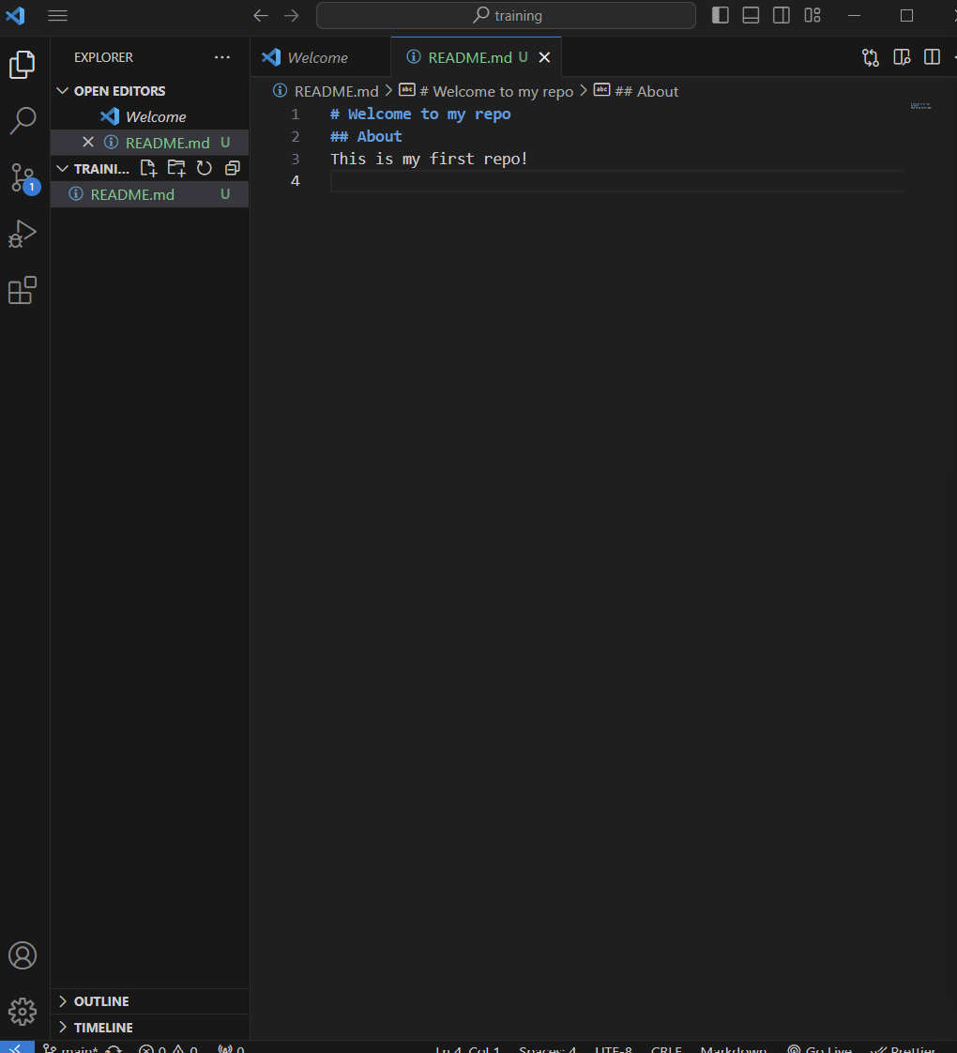

**Note:** create a new file by selecting the +folder sign at the upper right-hand corner of the above screen and not directly from the file menu

**Step 8.** Save this file and then return to the GitHub Desktop Client. It should now show that there are changes in your local copy which have not yet been committed. You will know this because files will appear in the left panel and on the comparison panel located on the right (see image below).

**Step 9.** Let’s now commit this new file. In the bottom left corner of the window is two field. The first is a title field and the second is a description. Inside the first field write “***My first commit***” and then leave the description field blank. Now, click “Commit to main” and “publish”.

**Step 10.** The window will update to show that there are no longer any local changes. However, if you return to your web browser you will see that nothing has been pushed to GitHub. To do this, you must click the third tab named “Publish branch”. After a few moments your first push would have completed successfully.

**Step 11.** Now, if you return to your web browser and refresh your repository, you should see the README file we just created (see below)!

**Independent Activity**

It is recommended that you also use GitHub to store the files for your in-class work. Create a repository for this now.

**That’s it for this activity!** From this point forward, you should remember to complete steps 10 to 11 at regular intervals as you progress through the assessment.